Inner South West Sydney Housing Affordability Analysis

Executive Summary
The Inner South West housing market shows a clear transition from a relatively balanced sales–rental market in 2022 to a rent-led affordability problem from 2023 onward. By 2025-Q3, rental growth remained substantially ahead of sales-price growth, even though transaction activity had recovered strongly.
Drilling below the regional trend shows that this pressure is not uniform. Highly active suburbs generally display rent-led affordability pressure with comparatively moderate purchase affordability, while several lower-activity suburbs face combined rental and purchase pressure. Other weak and volatile sales markets experienced very strong rental escalation followed by some recent moderation.
The segment analysis provides an additional explanation for this divergence. The earlier rental shock was broad enough to affect the dominant Flat/Unit and 2-bedroom markets, but these high-volume segments have recently begun to stabilise at elevated burden levels. In contrast, houses, townhouses and 3-bedroom-plus properties continue to show greater and, in some cases, rising affordability pressure.
External evidence is consistent with this interpretation. Domain's March 2026 Sydney rental results indicate that rents can flatten even while vacancy remains exceptionally tight when renters reach affordability limits. Separately, the Committee for Sydney/BDO identifies a longer-term shortage of family-sized housing, with 3-bedroom dwelling stock growing much more slowly than 1- and 2-bedroom stock and affordability for family-sized rental accommodation deteriorating sharply across Sydney.

Regional Position at 2025-Q3
At the latest dashboard period, Inner South West recorded the following indicators:
Indicator | 2025-Q3
Median Sales Price | ~$1.21 million
Median Weekly Rent | ~$716.50
Price-to-Income Ratio | ~12.6x
Rent Burden | ~39.8%
Total Regional Sales | ~2,085

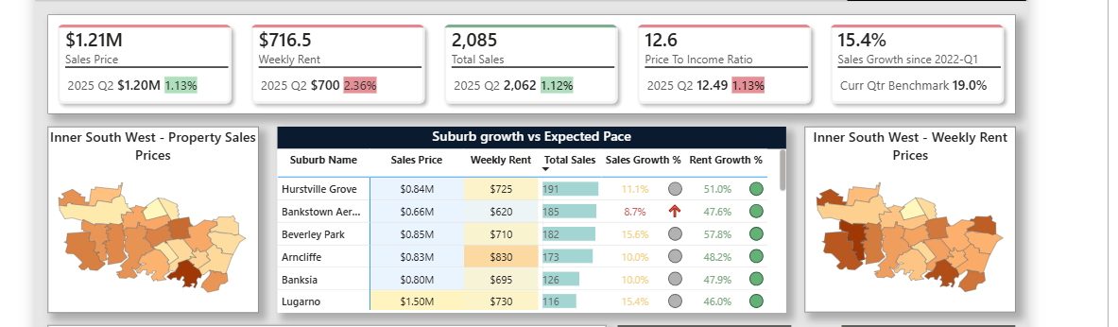
2025-Q3 Snapshot of Inner South West region
The initial regional finding is therefore not simply that Inner South West is expensive. Its rental burden is substantial even though its absolute rents remain below those observed in inner-city Sydney.
More importantly, the region's Rent vs CPI trend shows that rents had moved approximately 30% or more above their CPI-implied path by the end of the analysis period. This indicates that the deterioration in rental affordability cannot be explained solely by general inflation.

Development of the Rent–Sales Divergence
Using the common 20-suburb snapshots, the market changed considerably between 2022 and 2025.
Period | Median Sales Growth* | Median Rent Growth* | Rent–Sales Gap | Sales Activity
2022-Q2 | +1.1% | +3.2% | ~1.3 pp | 1,728
2023-Q1 | -7.9% | +18.8% | ~27.6 pp | 1,374
2024-Q1 | +3.5% | +43.8% | ~39.1 pp | 1,730
2025-Q1 | +8.4% | +44.4% | ~41.6 pp | 1,511
2025-Q3 | +14.2% | +48.1% | ~38.6 pp | 2,013
Growth relative to the fixed 2022-Q1 baseline.

Three Distinct Market Phases
2022: Relative Alignment
Rent and sales-price movements were relatively aligned during the early part of the analysis period.
2023-2024: Rapid Rental Divergence
Rental growth accelerated substantially while sales prices initially weakened and subsequently recovered. The gap between rental and sales growth widened from approximately 1 percentage point to almost 40 percentage points.
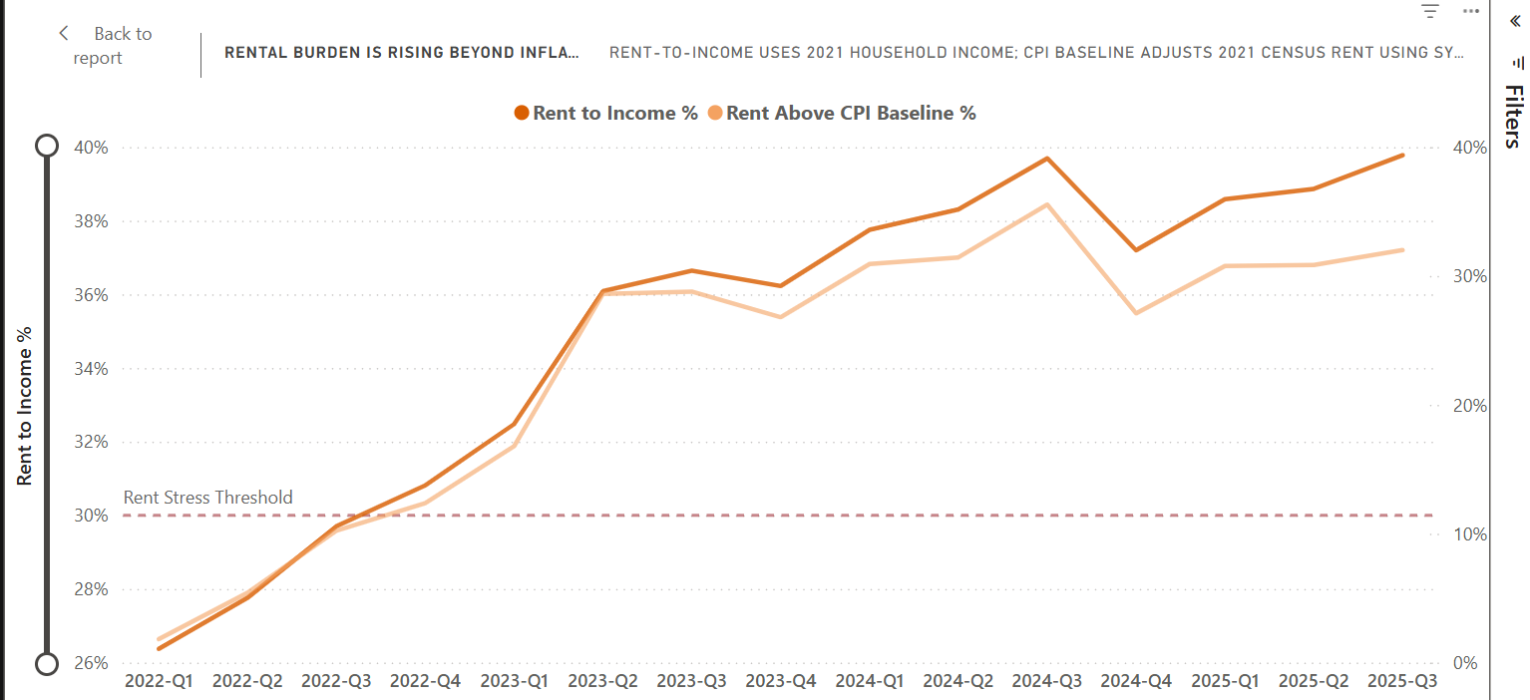
Rental stress has far exceeded the 30% stress threshold: Sydney Inner South West
2025: Ownership Recovery Without Rental Reversal
By 2025, sales-price growth had strengthened and transaction activity reached its highest observed level. However, rental growth remained close to 50% above the 2022-Q1 benchmark.
This finding is important because the rental divergence survived the recovery of the ownership market. Weak property sales therefore cannot, by themselves, explain the continuation of rental affordability pressure.
The slight reduction in the rent–sales gap from approximately 41.6 percentage points in 2025-Q1 to 38.6 percentage points in 2025-Q3 may also indicate that the market has entered a different phase. Sales prices were beginning to catch up while parts of the rental market were no longer accelerating at the same rate.

Suburb-Level Affordability Patterns
The suburb-level analysis demonstrates that the regional average contains three distinct market conditions.

Highly Active Suburbs: Predominantly Rent-Led Pressure
Several of the region's largest sales markets show comparatively moderate purchase pressure but substantial rental deterioration.
Suburb | Sales | Rent Burden | Price-to-Income | Rent vs CPI
Arncliffe | 173 | 39.2% | 7.5x | +31.5%
Hurstville Grove | 191 | 39.4% | 8.8x | +27.1%
Bankstown Aerodrome | 185 | 44.5% | 9.1x | +24.6%
Banksia | 126 | 38.8% | 8.5x | +24.5%

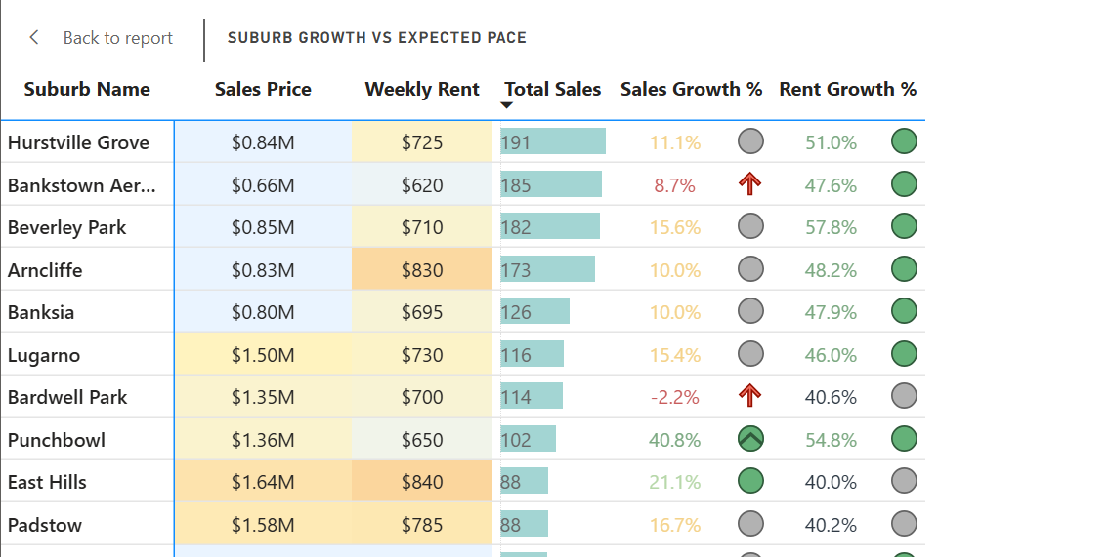
Suburb level Outlook: Sydney Inner South West 2025 -Q3
These areas are particularly important because high rental pressure is occurring despite functioning and relatively active ownership markets.
This does not imply that purchasing is affordable in absolute terms. Rather, relative to other Inner South West suburbs, the rental side of the market has deteriorated disproportionately compared with the purchase side.

Combined-Pressure Suburbs
A second group of suburbs faces substantially greater affordability pressure across both tenure types.
Examples include:
- Lugarno: 43.2% rent burden, 17.1x Price-to-Income and +62.6% Rent vs CPI
- Punchbowl: 43.9% rent burden, 17.7x Price-to-Income and +33.9% Rent vs CPI
- Padstow: 41.4% rent burden, 16.0x Price-to-Income and +37.6% Rent vs CPI
- East Hills: 39.7% rent burden, 14.9x Price-to-Income and +47.3% Rent vs CPI
These suburbs generally record less sales activity than the largest rent-led markets. The regional affordability problem therefore cannot be characterised as a single market condition. Some suburbs primarily face rental pressure, while others experience significant affordability constraints in both renting and purchasing.

Weak or Volatile Sales Markets Where Rents Still Surged
Mortdale, Belmore and Bardwell Park demonstrate a third market behaviour.
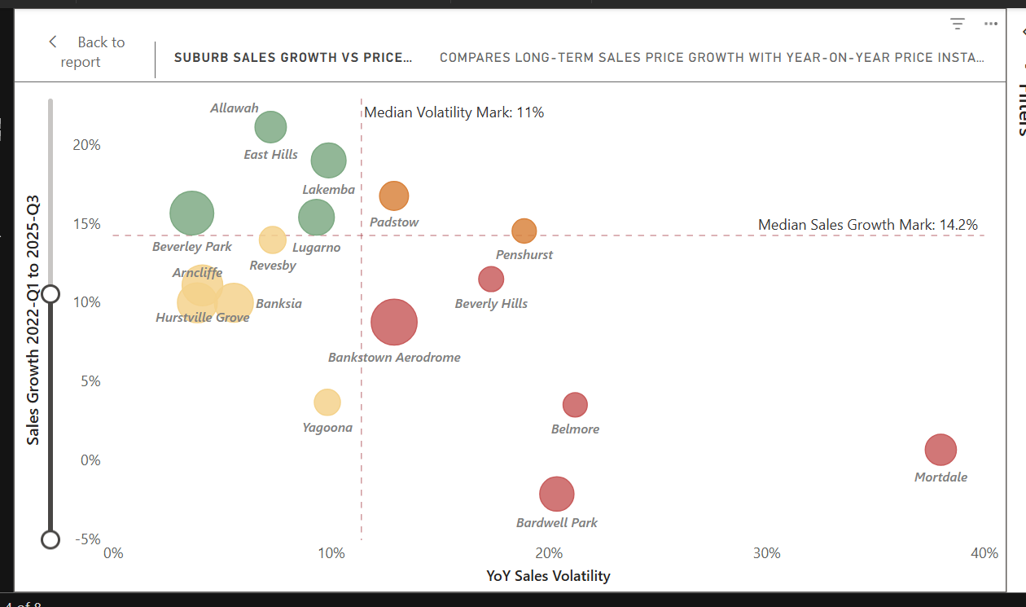
YoY Sales Volatility vs growth Rates of different Subrubs: Sydney Inner South West
By 2025-Q3:
- Mortdale: sales growth of only +0.6%, compared with rent growth of +44.4%
- Belmore: sales growth of +3.5%, compared with rent growth of +55.3%
- Bardwell Park: sales growth of -2.2%, compared with rent growth of +40.6%
These suburbs experienced relatively weak sales-price growth and greater sales-market volatility, yet rental prices still increased dramatically.
There is also evidence of recent moderation rather than a complete reversal. Mortdale, for example, reached approximately +55.6% rent growth in 2025-Q1 before easing to +44.4% by 2025-Q3, while Belmore remained around the mid-50% range following its earlier surge.
This distinction becomes particularly important when the rental segment findings are considered.

What Is Happening Inside the Rental Market?
The segment analysis suggests that the broad rental shock identified at the regional and suburb levels is now changing in composition.

Dwelling-Type Analysis
Dwelling Type | 2025-Q3 Rent | Rent Burden | Rent vs CPI | New Bonds
Flat/Unit | $610 | 33.1% | +12.4% | 2,779
House | $837.50 | 45.5% | +54.3% | 1,183
Townhouse | $877.50 | 47.7% | +61.7% | Lower/thinner sample
Other | $600 | 32.6% | +10.5% | —
The Flat/Unit market is the dominant rental segment by bond activity. Its Burden Index increased sharply from the 2022-Q1 baseline and reached approximately 150. However, its recent rent and burden trajectory has become broadly stable.
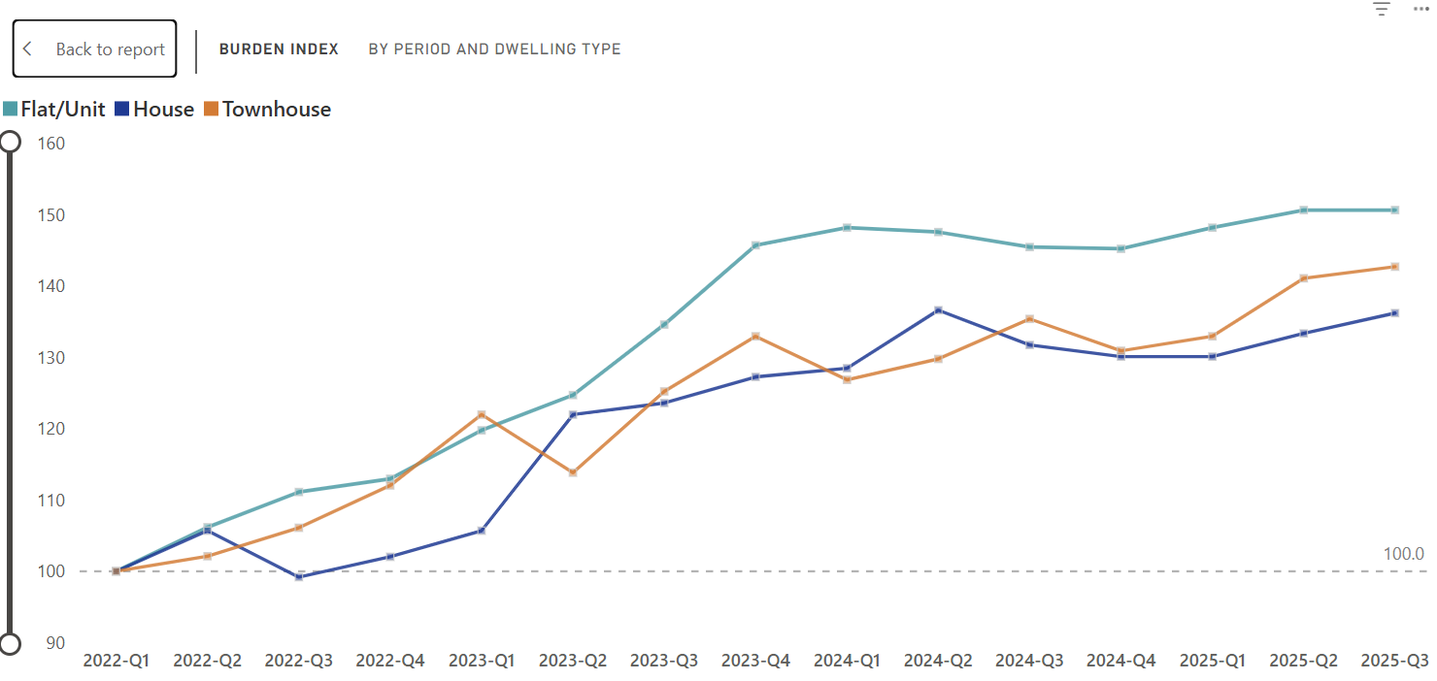
Burden Index by Dwelling Types: Sydney Inner South West region
Houses and townhouses display a different pattern. They have:
- substantially higher current rent burdens;
- rents considerably further above their CPI-implied benchmarks; and
- stronger recent upward trajectories.
The latest regional affordability pressure therefore increasingly appears to be concentrated in larger dwelling configurations, rather than continuing to accelerate equally across all rental stock.

Bedroom Count Analysis
The bedroom-level analysis reinforces the same pattern.
Bedroom Count | Weekly Rent | Rent Burden | Rent vs CPI | New Bonds
1BR | $538 | 29.2% | -0.9% | 479
2BR | $620 | 33.7% | +14.2% | 1,884
3BR | $820 | 44.6% | +51.1% | 330
4+ BR | $1,163 | 63.2% | +114.2% | 162

The 2-bedroom market is overwhelmingly the most active bedroom segment. Its Burden Index experienced one of the largest increases from the 2022-Q1 baseline, reaching approximately 150, but has gradually eased during the most recent quarters.
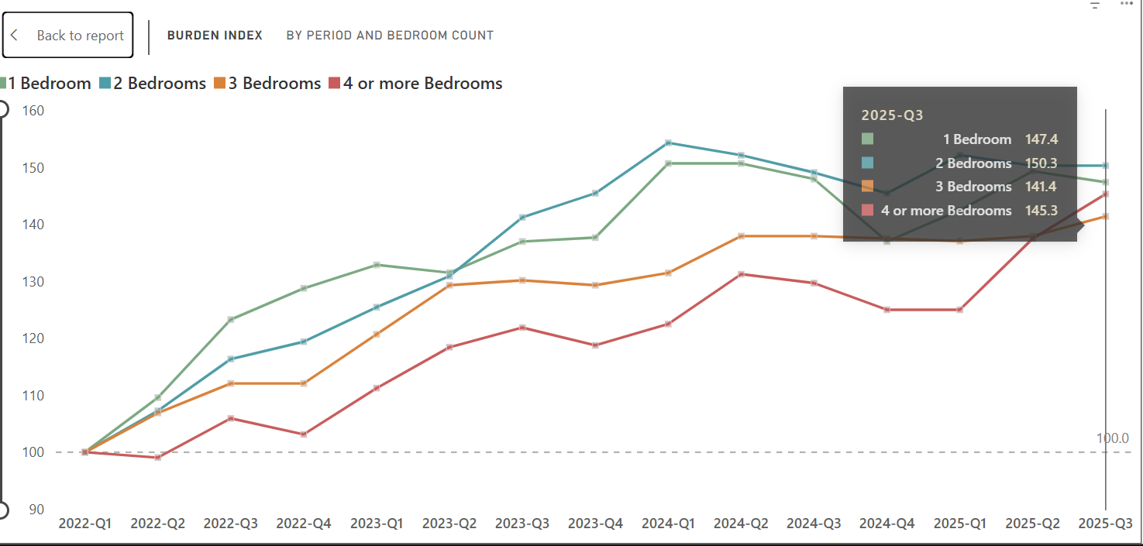
Rent Burden by Bedroom Counts: Sydney Inner South West Region
By contrast, the rent-burden trajectories for 3-bedroom and 4+-bedroom properties have continued upward.
Recent bond activity also makes the 3-bedroom segment particularly notable. Reported new rental bonds for 3BR properties increased from 98 in 2025-Q2 to 330 in 2025-Q3, a 236.7% quarter-on-quarter increase and the highest 3BR count observed across the analysis period. This was substantially stronger than the corresponding increases for 1BR (+29.5%), 2BR (+15.8%) and 4+BR (+9.5%). While new bond lodgements should not be interpreted as a direct measure of rental demand, the increase indicates that the 3BR segment became considerably more active at the same time that its rent burden remained high at 44.6% and rents were 51.1% above their CPI-adjusted benchmark.
This produces an important distinction, the most recent deterioration is increasingly concentrated in larger housing segments, which remain lower-volume overall but are showing signs of increased market activity
The region's 2021 average household size of approximately 2.8 persons adds relevance to this finding. Two-bedroom housing is clearly a major mainstream rental configuration, but households requiring additional bedrooms now encounter a substantially steeper affordability premium.
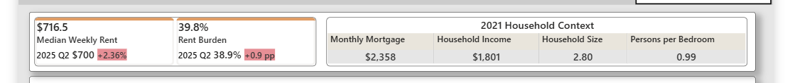
2021 Household Income Context: Sydney Inner South West region
However, these results do not prove that renters are moving from 2-bedroom into 3-bedroom properties, nor that particular suburbs' rental increases are directly caused by their dwelling mix. A suburb-by-bedroom or suburb-by-dwelling cross-tabulation would be required to establish such relationships.

External Evidence: Stabilising Rents Do Not Necessarily Mean Pressure Has Disappeared
The recent flattening of Flat/Unit and 2-bedroom trajectories could easily be interpreted as evidence of an improving rental market. However, later Sydney-wide evidence from Domain supports a more cautious interpretation.
In March 2026, after the period covered by this dashboard, Sydney's overall rental vacancy rate reached 0.8%, while median house rents remained unchanged at $800 per week and unit rents remained unchanged at $750 per week quarter-on-quarter.
Domain interpreted the combination of exceptionally tight vacancies and flat rental prices as evidence that affordability had become a binding constraint: renters had limited capacity to absorb further increases despite continued supply constraints.
This later Sydney-wide evidence is consistent with the pattern beginning to emerge in Inner South West by 2025-Q3.
Mortdale, Belmore and Bardwell Park are particularly relevant examples. Each experienced substantial rental growth despite weak or volatile sales-market performance, followed by varying degrees of moderation.
Rent growth easing from extremely high levels does not necessarily mean affordability pressure has been removed. It may instead indicate that the market is encountering the limits of what tenants can continue paying.
This interpretation is also consistent with the Flat/Unit and 2-bedroom segment results. Both experienced substantial cumulative increases and now show signs of stabilisation, while their Burden Index values remain approximately 50% above their 2022-Q1 starting levels.
A reasonable interpretation is therefore:
Inner South West's mainstream rental market may have moved from rapid escalation into a high-cost plateau, rather than returning to its earlier affordability position.
Importantly, Domain's March 2026 evidence should be treated as later corroborating evidence of a plausible market mechanism, rather than proof of what caused Inner South West rents to flatten during 2025.

External Evidence: Pressure on Family-Sized Housing
The second external source provides context for why larger rental configurations may be behaving differently.
The Committee for Sydney/BDO State of the City 2026 report finds that between 2011 and 2021, Sydney's dwelling stock changed substantially by bedroom configuration:
- 1-bedroom dwelling stock increased by 50%
- 2-bedroom dwelling stock increased by 27%
- 3-bedroom dwelling stock increased by only 3%
The report interprets this as evidence of a widening mismatch between the demand for family-sized housing and its supply.
It also finds that by 2025, 3-bedroom apartments were unaffordable in more than 116 Sydney postcodes, compared with 69 postcodes in 2021.
Within areas relevant to the broader Inner South West context:
- Greenacre recorded an approximately 38 percentage-point deterioration in rent-to-income affordability
- Sans Souci/Dolls Point deteriorated by approximately 36 percentage points
The report also identifies Bankstown among major centres with relatively high insufficient-bedroom or overcrowding measures and reports Lakemba at approximately 27%, further highlighting the importance of sufficient dwelling space within this part of Sydney.

Alignment with the Dashboard Segment Results
The external evidence aligns closely with the segment patterns observed in the dashboard.
Mainstream Smaller Rental Stock
- 2BR: 1,884 bonds, 33.7% rent burden and +14.2% Rent vs CPI
- Flat/Unit: 2,779 bonds, 33.1% rent burden and +12.4% Rent vs CPI
- Both segments show recent signs of stabilisation
Larger Rental Stock
- 3BR: 44.6% rent burden and +51.1% Rent vs CPI
- House: 45.5% rent burden and +54.3% Rent vs CPI
- 4+ BR: 63.2% rent burden and +114.2% Rent vs CPI
- Townhouse: 47.7% rent burden and +61.7% Rent vs CPI
- Several of these segments continue to show upward trajectories
The Committee for Sydney has also highlighted the difficulty of finding family-friendly apartments in Canterbury-Bankstown and the area's relatively large household structure, raising concerns regarding the limited diversity of larger apartment configurations.

Connection to Suburb-Level Affordability Pressure
The suburb analysis demonstrates that the broader affordability issue is already material within locations relevant to this structural context.
Examples include:
- Punchbowl: 43.9% rent burden and 17.7x Price-to-Income
- Lugarno: 43.2% rent burden and rents 62.6% above CPI
- East Hills: 39.7% rent burden and +47.3% Rent vs CPI
- Lakemba: rent burden increased from approximately 26.7% to 42.1%, while Rent vs CPI moved from -11.1% to +22.4%
These results do not prove that a shortage of 3-bedroom housing directly caused the affordability outcomes observed within individual suburbs.
However, they demonstrate that substantial affordability pressure exists within the same broader geography where external evidence identifies structural problems concerning family-sized housing availability and sufficient bedroom space.
This supports the following interpretation:
The growing pressure in houses and 3BR+ rentals is consistent with a longer-term mismatch between the supply of family-sized housing and the needs of larger households. Inner South West's rental problem may therefore be evolving from a broad market-wide rent shock into a more uneven affordability problem in which obtaining additional living space carries an increasingly large premium.

Integrated Interpretation
Across the four analytical layers, the evidence suggests a transition rather than a single static affordability problem.

Broad Rental Shock
First, Inner South West experienced a broad rental shock. Rent and sales growth were relatively aligned in early 2022, but rental prices accelerated dramatically from 2023 onward and remained almost 50% above the 2022-Q1 baseline by 2025-Q3.

Geographically Broad Impact
Second, the shock was geographically broad. It appeared across:
- highly active ownership markets;
- combined-pressure suburbs; and
- weak or volatile sales markets.
Therefore, no single type of sales-market behaviour adequately explains the rental escalation.

Material Affordability Consequences
Third, the suburb-level affordability measures demonstrate that the escalation was economically meaningful.
Some highly active suburbs are predominantly rent-led, while other locations face substantial pressure across both renting and purchasing.

Changing Composition of Rental Pressure
Finally, the segment analysis indicates that the nature of the affordability problem appears to be changing.
The dominant Flat/Unit and 2-bedroom markets experienced the broadest earlier increase but have recently begun to stabilise at elevated levels.
By contrast, houses, townhouses and 3-bedroom-plus properties display:
- substantially greater current affordability pressure;
- larger deviations from their CPI-implied rental paths; and
- continued recent increases in several segments.

Overall Finding
The two external sources provide plausible context for this transition.
Domain's later Sydney-wide evidence suggests that the flattening of mainstream rental prices can occur because affordability ceilings are reached even while the rental market remains supply constrained.
The Committee for Sydney/BDO provides a longer-term structural explanation for why larger housing may remain under greater pressure: family-sized dwelling supply has expanded considerably more slowly than smaller housing, while affordability for 3-bedroom accommodation has deteriorated substantially across Sydney.
The overall finding is therefore:
Inner South West appears to have moved from broad-based rental escalation toward a more uneven affordability environment. Mainstream 2BR and Flat/Unit rents are beginning to stabilise, but at burden levels far above their 2022 baseline, while households requiring larger housing continue to face increasing pressure. The region's affordability challenge may therefore be shifting from simply paying more for rental housing to paying a progressively larger premium for additional living space.
This conclusion is supported by the dashboard analysis, while the external literature should be treated as contextual explanation and corroborating evidence rather than causal proof.

Post-period validation — Q4 2025 to mid-2026
Evidence published after the dashboard period broadly supports the interpretation that Inner South West was entering a more fragmented phase rather than experiencing uniform rental relief. Sydney-wide rental growth initially moderated around late 2025 and early 2026 despite exceptionally tight vacancy, with Domain attributing the pause to renters reaching affordability limits rather than a disappearance of supply pressure. Growth subsequently reaccelerated in June 2026, indicating that stabilisation at elevated rents did not necessarily represent a sustained reversal.
Within Inner South West itself, May-2026 vacancy data also showed substantial geographic variation—from 2.0% in Hurstville and 2.4% in Kogarah–Rockdale to 8.8% in Canterbury—supporting the dashboard's finding that affordability and rental-market conditions were becoming increasingly localised. Post-period asking-rent data further continued to show a substantial premium for 3–4BR accommodation across several areas represented in the dashboard.
Taken together, the post-period evidence does not change the four-layer conclusion. Instead, it strengthens it: the broad rental shock seen through 2025-Q3 appears to have evolved into a more uneven market, with temporary affordability-driven moderation in mainstream rental stock, persistent pressure on larger housing, and increasingly different conditions across individual Inner South West submarkets.

Data Sources

Rent and Sales Datasets
Primary market data for residential rentals and property sales were collected from the NSW Department of Communities and Justice (DCJ). The dataset comprises quarterly spreadsheets covering 15 consecutive quarters, ranging from Issue 139 (March 2022 quarter) through Issue 153 (September 2025 quarter).
Scope & Metrics:
The rental datasets capture total rental bond lodgements, median weekly rent prices ($), and 12-month percentage changes segmented by property type (e.g., 1/2/3+ bedroom flats/houses) across Local Government Areas (LGAs) and postcode zones in New South Wales. Sales datasets detail quarterly median residential sale prices and transaction volumes across Greater Sydney and Rest of NSW regions.

Census 2021 Data
Australian Bureau of Statistics. (2021). Census of Population and Housing: General Community Profile, New South Wales, Suburbs and Localities (SAL). ABS. abs.gov.au

Consumer Price Index Data
Australian Bureau of Statistics. (2026, June). Consumer Price Index, Australia. ABS. https://www.abs.gov.au/statistics/economy/price-indexes-and-inflation/consumer-price-index-australia/latest-release.

Supporting Article References
Domain. Rental Report — March 2026.
https://www.domain.com.au/research/rental-report/march-2026/
Domain. Rental Pressure Persists as Affordability Hits Firm Ceiling.
https://www.domain.com.au/group/media-releases/rental-pressure-persists-as-affordability-hits-firm-ceiling/
Committee for Sydney / BDO. State of the City 2026: A Bold City.
https://sydney.org.au/wp-content/uploads/2026/02/State-of-the-City-2026-A-bold-city.pdf
Committee for Sydney. New Space Race — The Plan to Improve Child-Friendly Apartment Living for Bigger Families.
https://sydney.org.au/new-space-race-the-plan-to-improve-child-friendly-apartment-living-for-bigger-families/
Domain Rental Report — December 2025: supports the shift toward slower, more selective rental growth; Sydney houses reached $800/week (+1.3% QoQ) while units held at $750 (0% QoQ).
Domain December 2025 Rental Report
Domain Rental Report — March 2026: supports the affordability-ceiling interpretation. Sydney house and unit rents were both flat quarter-on-quarter at $800 and $750, despite vacancy tightening to 0.8%.
Domain March 2026 Rental Report
Domain — June Quarter 2026 Rent Report / July 2026 release: useful as the later postscript showing that the earlier plateau was not necessarily a permanent reversal; Sydney house rents subsequently jumped $50 to $850/week in the June quarter.
Domain June 2026 rental update
Suburbtrends — Sydney Inner South West, May 2026: this is the strongest region-specific post-period source. It reports a weighted Inner South West vacancy rate of 4.2%, but with substantial internal variation: Hurstville 2.0%, Kogarah–Rockdale 2.4%, Bankstown 3.9%, Canterbury 8.8%. It also contains the later asking-rent data by dwelling/bedroom configuration.
Suburbtrends — Sydney Inner South West

